Post 1575 Brick order forms.
Anyone considering getting a brick for someone they honor and respect please read the information below on how to do so. We need to order the bricks in 'batches' to avoid an extra charge for 'small orders' and to get free shipping.

Our American Legion Katonah Post and Squadron 1575 continues to fill-out our Honor Wall with Remembrance Bricks (see pic in attached word doc).
The attached request order form and logo sheet may be used to request a brick or bricks.
You may:
- Mail to me: Thom Newman 40 Allison Rd. Katonah, NY 10536,
- Drop at Legion: Please let me know if you do so I can go by and pick it up
- E-mail me your requests. thomnewm@verizon.net
Checks should be made out to: Post 1575 Katonah, NY

A brick may be requested by anyone; you need not be a veteran or affiliated with the American Legion. Most of our brick requests so far have been from people who wanted to remember a family member or friend who may or may not have served in the military...just someone they thought was a good person.
The attached "logo sheet' shows many of the available 'logos'
In addition to the Logos on the sheet, we can add a Custom Logo, such as a unit patch, ship name, organization symbol, etc. Just include a high-quality image of the desired logo. Many can be found via a Google search. All logos will be printed on the brick in 'black and white'. Regrettably, we cannot add bricks depicting animals unless it for a military service dog.

Please feel free to pass this information to family and friends as all may participate and are welcome.
Post 1575 reserves the right decline requests that it determines to be inappropriate for the wall.

Remember.....you need not be a member of the Legion to come in as a 'guest' of the Legion...just sign the guest log book in the lounge.
We are open 12 noon to 8 PM daily. Often on Friday or Saturday we may be open a bit later.
All here thank you for your support.
If you have questions about the 'Brick' or Post 1575; e-mail me at thomnewm@verizon.net
Kindest regards, Thom N

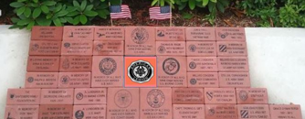
FILL OUT FORM. Place in an envelope with check ...mark it BRICK and your name on outside of envelope. You may:
- Mail to me: Thom Newman 40 Allison Rd. Katonah, NY 10536,
- Drop at Legion: Please let me know if you do so I can go by and pick it up
- E-mail me your requests. thomnewm@verizon.net

Checks should be made out to: Katonah American Legion

Name:_____________________________________________________ Date:_________

Phone #: ___________________________email: _____________________________________

Make check for $100 to Katonah American Legion; check #___________

If you want a logo, get the Logo # from logo # ________

In addition to the Logos on the sheet, we can add a Custom Logo, such as a unit patch, ship name, organization etc. Just include a high-quality image of the desired logo.
Logo Brick is limited to 15 characters or spaces on each of 3 lines.
Text will be automatically centered on each line by the brick manufacturer
(Logo shown below is an example to show where your logo will go)
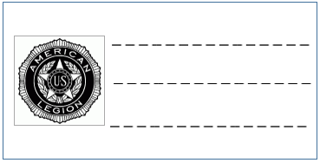

Name:_____________________________________________________ Date:_________

Phone #: ___________________________email: _____________________________________

Make check for $100 to Katonah American Legion; check #___________

Non-Logo Brick is limited to 20 characters or spaces on each of 3 lines.
Text will be automatically centered on each line by the brick manufacturer
Put the letter you want above each line:
